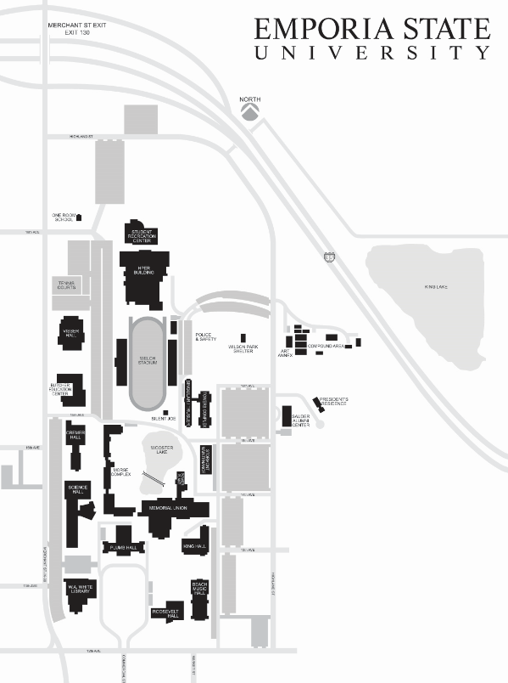

**FALL 2017**

VETERANS’ BANNER POSITIONS 5 TO 32

**VETERANS’ BANNER LOCATIONS**

VETERANS’ BANNER POSITIONS 33 TO 36

VETERANS’ BANNER POSITION 47 TO 50

VETERANS’ BANNER POSITIONS 37 TO 46

VETERANS’ BANNER POSITIONS 1 TO 4

VETERANS’ BANNER POSITIONS 51 TO 60